Chapter 16

Concurrency Control

Lock-Based Protocols

Timestamp-Based Protocols

Validation-Based Protocols

Multiple Granularity

Multiversion Schemes

Insert and Delete Operations

Concurrency in Index Structures

Lock-Based Protocols

A lock is a mechanism to control concurrent access to a data item

Data items can be locked in two modes :

1. exclusive (X) mode. Data item can be both read as well as

written. X-lock is requested using lock-X instruction.

2. shared (S) mode. Data item can only be read. S-lock is

requested using lock-S instruction.

Lock requests are made to concurrency-control manager. Transaction can proceed only after request is granted.

Lock-compatibility matrix

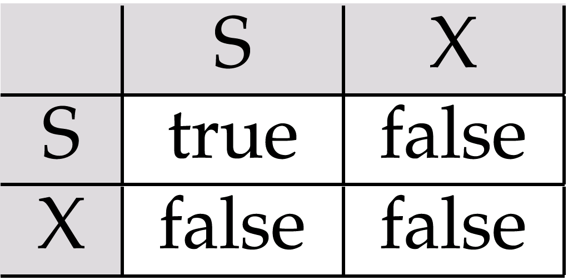

A transaction may be granted a lock on an item if the requested lock is compatible with locks already held on the item by other transactions

Any number of transactions can hold shared locks on an item,

but if any transaction holds an exclusive on the item no other transaction may hold any lock on the item.

If a lock cannot be granted, the requesting transaction is made to wait till all incompatible locks held by other transactions have been released. The lock is then granted.

Example of a transaction performing locking:

T₂: lock-S(A);

read (A);

unlock(A);

lock-S(B);

read (B);

unlock(B);

display(A+B)

Locking as above is not sufficient to guarantee serializability — if A and B get updated in-between the read of A and B, the displayed sum would be wrong.

A locking protocol is a set of rules followed by all transactions while requesting and releasing locks. Locking protocols restrict the set of possible schedules.

Pitfalls of Lock-Based Protocols

Consider the partial schedule

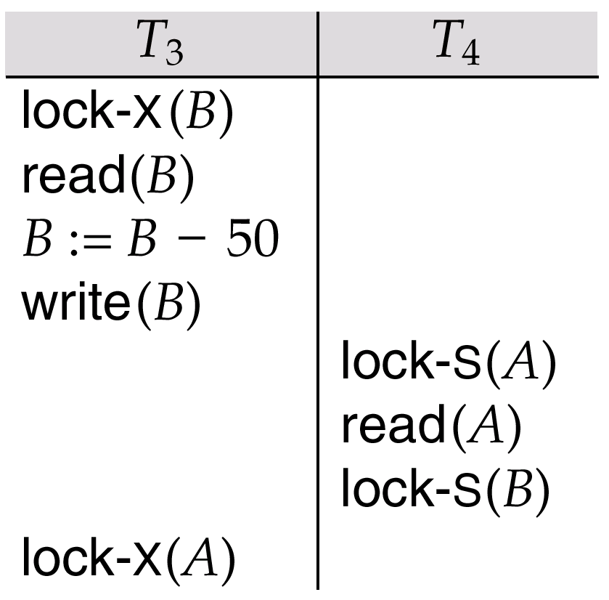

Neither T₃ nor T₄ can make progress — executing lock-S(B) causes T₄ to wait for T₃ to release its lock on B, while executing lock-X(A) causes T₃ to wait for T₄ to release its lock on A.

Such a situation is called a deadlock.

To handle a deadlock one of T₃ or T₄ must be rolled back
and its locks released.

The potential for deadlock exists in most locking protocols. Deadlocks are a necessary evil.

Starvation is also possible if concurrency control manager is badly designed. For example:

A transaction may be waiting for an X-lock on an item, while a sequence of other transactions request and are granted an S-lock on the same item.

The same transaction is repeatedly rolled back due to deadlocks.

Concurrency control manager can be designed to prevent starvation.

The Two-Phase Locking Protocol

This is a protocol which ensures conflict-serializable schedules.

Phase 1: Growing Phase

transaction may obtain locks

transaction may not release locks

Phase 2: Shrinking Phase

transaction may release locks

transaction may not obtain locks

The protocol assures serializability. It can be proved that the transactions can be serialized in the order of their lock points (i.e. the point where a transaction acquired its final lock).

Two-phase locking does not ensure freedom from deadlocks

Cascading roll-back is possible under two-phase locking. To avoid this, follow a modified protocol called strict two-phase locking. Here a transaction must hold all its exclusive locks till it commits/aborts.

Rigorous two-phase locking is even stricter: here all locks are held till commit/abort. In this protocol transactions can be serialized in the order in which they commit.

There can be conflict serializable schedules that cannot be obtained if two-phase locking is used.

However, in the absence of extra information (e.g., ordering of access to data), two-phase locking is needed for conflict serializability in the following sense:

Given a transaction T_{i} that does not follow two-phase locking, we can find a transaction T_{j} that uses two-phase locking, and a schedule for T_{i} and T_{j} that is not conflict serializable.

Lock Conversions

Two-phase locking with lock conversions:

– First Phase:

can acquire a lock-S on item

can acquire a lock-X on item

can convert a lock-S to a lock-X (upgrade)

– Second Phase:

can release a lock-S

can release a lock-X

can convert a lock-X to a lock-S (downgrade)

This protocol assures serializability. But still relies on the programmer to insert the various locking instructions.

Automatic Acquisition of Locks

A transaction T_{i} issues the standard read/write instruction, without explicit locking calls.

The operation read(D) is processed as:

if T_{i} has a lock on D

then

read(D)

else begin

if necessary wait until no other

transaction has a lock-X on D

grant T_{i} a lock-S on D;

read(D)

end

write(D) is processed as:

if T_{i} has a lock-X on D

then

write(D)

else begin

if necessary wait until no other trans. has any lock on D,

if T_{i} has a lock-S on D

then

upgrade lock on D to lock-X

else

grant T_{i} a lock-X on D

write(D)

end;

All locks are released after commit or abort

Implementation of Locking

A lock manager can be implemented as a separate process to which transactions send lock and unlock requests

The lock manager replies to a lock request by sending a lock grant messages (or a message asking the transaction to roll back, in case of a deadlock)

The requesting transaction waits until its request is answered

The lock manager maintains a data-structure called a lock table to record granted locks and pending requests

The lock table is usually implemented as an in-memory hash table indexed on the name of the data item being locked

Lock Table

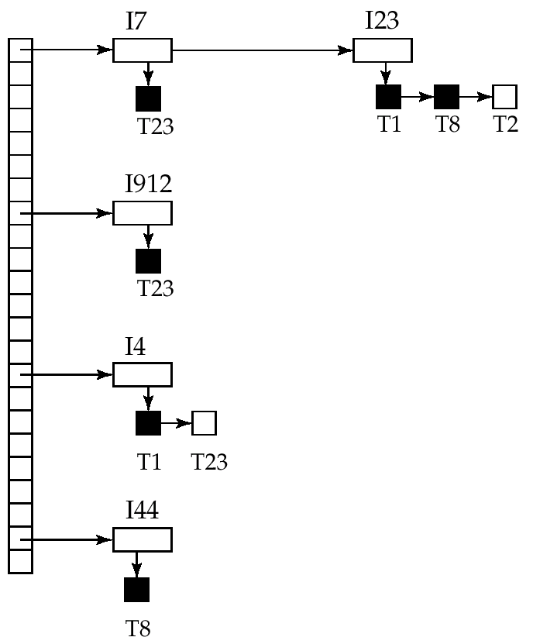

Black rectangles indicate granted locks, white ones indicate waiting requests

Lock table also records the type of lock granted or requested

New request is added to the end of the queue of requests for the data item, and granted if it is compatible with all earlier locks

Unlock requests result in the request being deleted, and later requests are checked to see if they can now be granted

If transaction aborts, all waiting or granted requests of the transaction are deleted

lock manager may keep a list of locks held by each transaction, to implement this efficiently

Graph-Based Protocols

Graph-based protocols are an alternative to two-phase locking

Impose a partial ordering → on the set D = {d₁, d₂ ,..., d_{h}} of all data items.

If d_{i} → d_{j} then any transaction accessing both d_{i} and d_{j} must access d_{i} before accessing d_{j}.

Implies that the set D may now be viewed as a directed acyclic graph, called a database graph.

The tree-protocol is a simple kind of graph protocol.

Tree Protocol

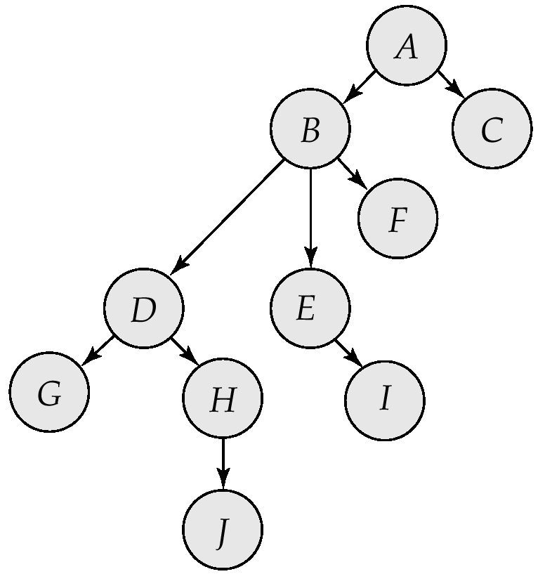

Only exclusive locks are allowed.

The first lock by T_{i} may be on any data item. Subsequently, a data Q can be locked by T_{i} only if the parent of Q is currently locked by T_{i}.

Data items may be unlocked at any time.

A data item that has been locked and unlocked by T_{i} cannot subsequently be relocked by T_{i}

The tree protocol ensures conflict serializability as well as freedom from deadlock.

Unlocking may occur earlier in the tree-locking protocol than in the two-phase locking protocol.

shorter waiting times, and increase in concurrency

protocol is deadlock-free, no rollbacks are required

Drawbacks

Protocol does not guarantee recoverability or cascade freedom

Need to introduce commit dependencies to ensure recoverability

Transactions may have to lock data items that they do not access.

increased locking overhead, and additional waiting time

potential decrease in concurrency

Schedules not possible under two-phase locking are possible under tree protocol, and vice versa.

Multiple Granularity

Allow data items to be of various sizes and define a hierarchy of data granularities, where the small granularities are nested within larger ones

Can be represented graphically as a tree (but don't confuse with tree-locking protocol)

When a transaction locks a node in the tree explicitly, it implicitly locks all the node's descendents in the same mode.

Granularity of locking (level in tree where locking is done):

fine granularity (lower in tree): high concurrency, high locking overhead

coarse granularity (higher in tree): low locking overhead, low concurrency

Example of Granularity Hierarchy

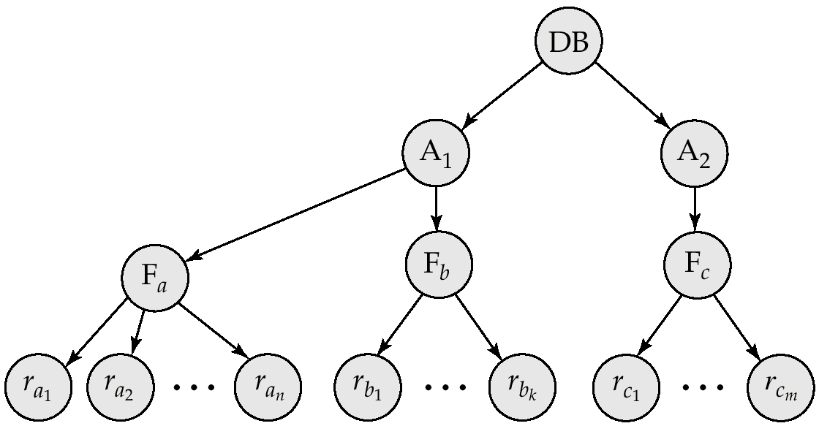

The levels, starting from the coarsest (top) level are

database

area

file

record

Intention Lock Modes

In addition to S and X lock modes, there are three additional lock modes with multiple granularity:

intention-shared (IS): indicates explicit locking at a lower level of the tree but only with shared locks.

intention-exclusive (IX): indicates explicit locking at a lower level with exclusive or shared locks

shared and intention-exclusive (SIX): the subtree rooted by that node is locked explicitly in shared mode and explicit locking is being done at a lower level with exclusive-mode locks.

intention locks allow a higher level node to be locked in S or X mode without having to check all descendent nodes.

Compatibility Matrix with Intention Lock Modes

The compatibility matrix for all lock modes is:
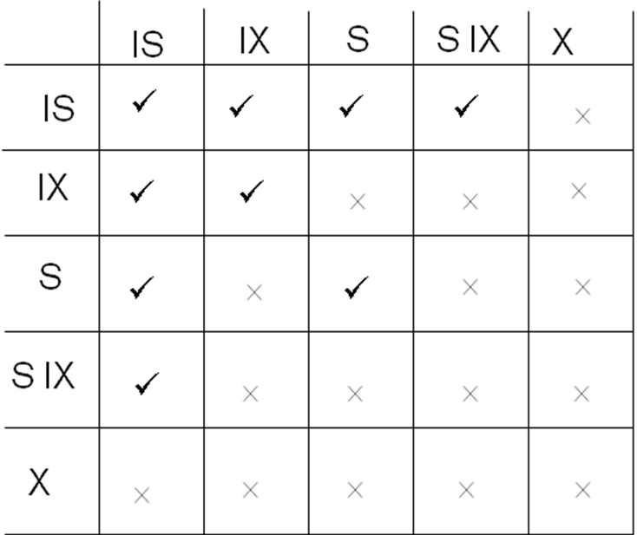

Multiple Granularity Locking Scheme

Transaction T_{i} can lock a node Q, using the following rules:

The lock compatibility matrix must be observed.

The root of the tree must be locked first, and may be locked in any mode.

A node Q can be locked by T_{i} in S or IS mode only if the parent of Q is currently locked by T_{i} in either IX or IS mode.

A node Q can be locked by T_{i} in X, SIX, or IX mode only if the parent of Q is currently locked by T_{i} in either IX or SIX mode.

T_{i} can lock a node only if it has not previously unlocked any node (that is, T_{i} is two-phase).

T_{i} can unlock a node Q only if none of the children of Q are currently locked by T_{i}.

Observe that locks are acquired in root-to-leaf order, whereas they are released in leaf-to-root order.

Deadlock Handling

Consider the following two transactions:

T₁: write (X) T₂: write(Y)

write(Y) write(X)

Schedule with deadlock

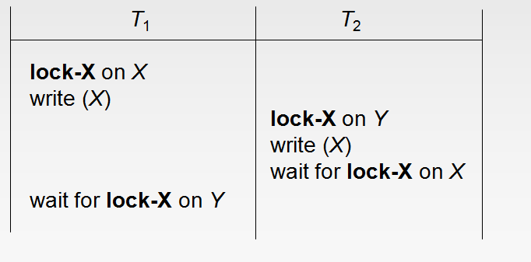

System is deadlocked if there is a set of transactions such that every transaction in the set is waiting for another transaction in the set.

Deadlock prevention protocols ensure that the system will never enter into a deadlock state. Some prevention strategies :

Require that each transaction locks all its data items before it begins execution (predeclaration).

Impose partial ordering of all data items and require that a transaction can lock data items only in the order specified by the partial order (graph-based protocol).

More Deadlock Prevention Strategies

Following schemes use transaction timestamps for the sake of deadlock prevention alone.

wait-die scheme — non-preemptive

older transaction may wait for younger one to release data item. Younger transactions never wait for older ones; they are rolled back instead.

a transaction may die several times before acquiring needed data item

wound-wait scheme — preemptive

older transaction wounds (forces rollback) of younger transaction instead of waiting for it. Younger transactions may wait for older ones.

may be fewer rollbacks than wait-die scheme.

Both in wait-die and in wound-wait schemes, a rolled back transactions is restarted with its original timestamp. Older transactions thus have precedence over newer ones, and starvation is hence avoided.

Timeout-Based Schemes :

a transaction waits for a lock only for a specified amount of time. After that, the wait times out and the transaction is rolled back.

thus deadlocks are not possible

simple to implement; but starvation is possible. Also difficult to determine good value of the timeout interval.

Deadlock Detection

Deadlocks can be described as a wait-for graph, which consists of a pair G = (V,E),

V is a set of vertices (all the transactions in the system)

E is a set of edges; each element is an ordered pair T_{i} →T_{j}.

If T_{i} → T_{j} is in E, then there is a directed edge from T_{i} to T_{j}, implying that T_{i} is waiting for T_{j} to release a data item.

When T_{i} requests a data item currently being held by T_{j}, then the edge T_{i} T_{j} is inserted in the wait-for graph. This edge is removed only when T_{j} is no longer holding a data item needed by T_{i}.

The system is in a deadlock state if and only if the wait-for graph has a cycle. Must invoke a deadlock-detection algorithm periodically to look for cycles.

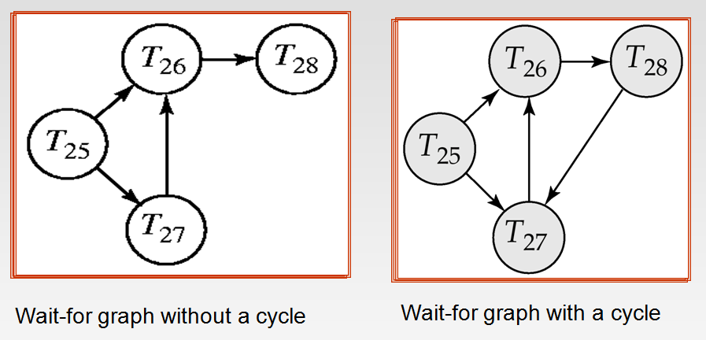

Deadlock Recovery

When deadlock is detected :

Some transaction will have to rolled back (made a victim) to break deadlock. Select that transaction as victim that will incur minimum cost.

Rollback -- determine how far to roll back transaction

Total rollback: Abort the transaction and then restart it.

More effective to roll back transaction only as far as necessary to break deadlock.

Starvation happens if same transaction is always chosen as victim. Include the number of rollbacks in the cost factor to avoid starvation

Other Approaches to Concurrency Control

Timestamp-Based Protocols

Each transaction is issued a timestamp when it enters the system. If an old transaction T_{i} has time-stamp TS(T_{i}), a new transaction T_{j} is assigned time-stamp TS(T_{j}) such that TS(T_{i}) <TS(T_{j}).

The protocol manages concurrent execution such that the time-stamps determine the serializability order.

In order to assure such behavior, the protocol maintains for each data Q two timestamp values:

W-timestamp(Q) is the largest time-stamp of any transaction that executed write(Q) successfully.

R-timestamp(Q) is the largest time-stamp of any transaction that executed read(Q) successfully.

The timestamp ordering protocol ensures that any conflicting read and write operations are executed in timestamp order.

Suppose a transaction T_{i} issues a read(Q)

If TS(T_{i}) ≤ W-timestamp(Q), then T_{i} needs to read a value of Q that was already overwritten.

Hence, the read operation is rejected, and T_{i} is rolled back.

If TS(T_{i})≥ W-timestamp(Q), then the read operation is executed, and R-timestamp(Q) is set to max(R-timestamp(Q), TS(T_{i})).

Suppose that transaction T_{i} issues write(Q).

If TS(T_{i}) < R-timestamp(Q), then the value of Q that T_{i} is producing was needed previously, and the system assumed that that value would never be produced.

Hence, the write operation is rejected, and T_{i} is rolled back.

If TS(T_{i}) < W-timestamp(Q), then T_{i} is attempting to write an obsolete value of Q.

Hence, this write operation is rejected, and T_{i} is rolled back.

Otherwise, the write operation is executed, and W-timestamp(Q) is set to TS(T_{i}).

Example Use of the Protocol

A partial schedule for several data items for transactions with

timestamps 1, 2, 3, 4, 5

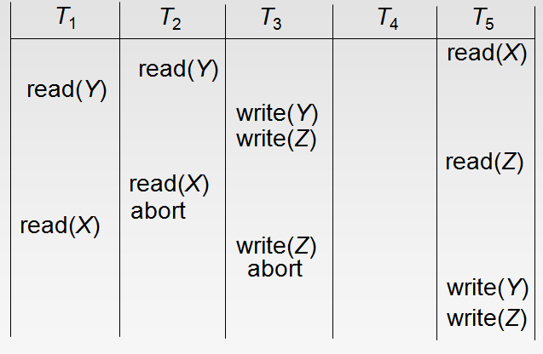

Correctness of Timestamp-Ordering Protocol

The timestamp-ordering protocol guarantees serializability since all the arcs in the precedence graph are of the form:

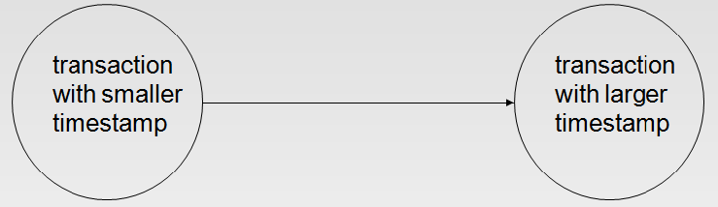

Thus, there will be no cycles in the precedence graph

Timestamp protocol ensures freedom from deadlock as no transaction ever waits.

But the schedule may not be cascade-free, and may not even be recoverable.

Recoverability and Cascade Freedom

Problem with timestamp-ordering protocol:

Suppose T_{i} aborts, but T_{j} has read a data item written by T_{i}

Then T_{j} must abort; if T_{j} had been allowed to commit earlier, the schedule is not recoverable.

Further, any transaction that has read a data item written by T_{j} must abort

This can lead to cascading rollback --- that is, a chain of rollbacks

Solution 1:

A transaction is structured such that its writes are all performed at the end of its processing

All writes of a transaction form an atomic action; no transaction may execute while a transaction is being written

A transaction that aborts is restarted with a new timestamp

Solution 2: Limited form of locking: wait for data to be committed before reading it

Solution 3: Use commit dependencies to ensure recoverability

Thomas’ Write Rule

Modified version of the timestamp-ordering protocol in which obsolete write operations may be ignored under certain circumstances.

When T_{i} attempts to write data item Q, if TS(T_{i}) < W-timestamp(Q), then T_{i} is attempting to write an obsolete value of {Q}.

Rather than rolling back T_{i} as the timestamp ordering protocol would have done, this {write} operation can be ignored.

Otherwise this protocol is the same as the timestamp ordering protocol.

Thomas' Write Rule allows greater potential concurrency.

Allows some view-serializable schedules that are not conflict-serializable.

Validation-Based Protocol

Execution of transaction T_{i} is done in three phases.

1. Read and execution phase: Transaction T_{i} writes only to

temporary local variables

2. Validation phase: Transaction T_{i} performs a ``validation test''

to determine if local variables can be written without violating

serializability.

3. Write phase: If T_{i} is validated, the updates are applied to the

database; otherwise, T_{i} is rolled back.

The three phases of concurrently executing transactions can be interleaved, but each transaction must go through the three phases in that order.

Assume for simplicity that the validation and write phase occur together, atomically and serially

I.e., only one transaction executes validation/write at a time.

Also called as optimistic concurrency control since transaction executes fully in the hope that all will go well during validation

Each transaction T_{i} has 3 timestamps

Start(T_{i}) : the time when T_{i} started its execution

Validation(T_{i}): the time when T_{i} entered its validation phase

Finish(T_{i}) : the time when T_{i} finished its write phase

Serializability order is determined by timestamp given at validation time, to increase concurrency.

Thus TS(T_{i}) is given the value of Validation(T_{i}).

This protocol is useful and gives greater degree of concurrency if probability of conflicts is low.

because the serializability order is not pre-decided, and

relatively few transactions will have to be rolled back.

Validation Test for Transaction T_{j}

If for all T_{i} with TS (T_{i}) < TS (T_{j}) either one of the following condition holds:

finish(T_{i}) < start(T_{j})

start(T_{j}) < finish(T_{i}) < validation(T_{j}) and the set of data items written by T_{i} does not intersect with the set of data items read by T_{j}.

then validation succeeds and T_{j} can be committed. Otherwise, validation fails and T_{j} is aborted.

Justification: Either the first condition is satisfied, and there is no overlapped execution, or the second condition is satisfied and

the writes of T_{j} do not affect reads of T_{i} since they occur after T_{i} has finished its reads.

the writes of T_{i} do not affect reads of T_{j} since T_{j} does not read any item written by T_{i}.

Schedule Produced by Validation

Example of schedule produced using validation

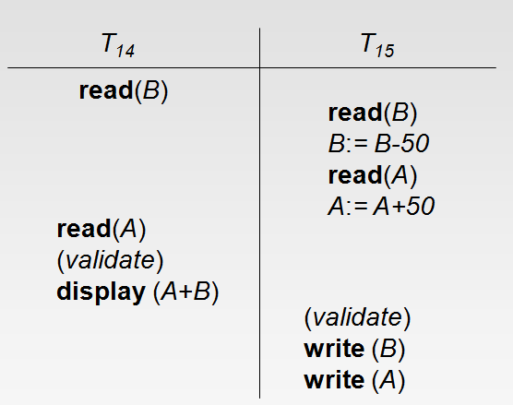

Multiversion Schemes

Multiversion schemes keep old versions of data item to increase concurrency.

Multiversion Timestamp Ordering

Multiversion Two-Phase Locking

Each successful write results in the creation of a new version of the data item written.

Use timestamps to label versions.

When a read(Q) operation is issued, select an appropriate version of Q based on the timestamp of the transaction, and return the value of the selected version.

reads never have to wait as an appropriate version is returned immediately.

Multiversion Timestamp Ordering

Each data item Q has a sequence of versions <Q₁, Q₂,...., Q_{m}>. Each version Q_{k} contains three data fields:

Content -- the value of version Q_{k}.

W-timestamp(Q_{k}) -- timestamp of the transaction that created (wrote) version Q_{k}

R-timestamp(Q_{k}) -- largest timestamp of a transaction that successfully read version Q_{k}

when a transaction T_{i} creates a new version Q_{k} of Q, Q_{k}'s W-timestamp and R-timestamp are initialized to TS(T_{i}).

R-timestamp of Q_{k} is updated whenever a transaction T_{j} reads Q_{k}, and TS(T_{j}) > R-timestamp(Q_{k}).

Suppose that transaction T_{i} issues a read(Q) or write(Q) operation. Let Q_{k} denote the version of Q whose write timestamp is the largest write timestamp less than or equal to TS(T_{i}).

If transaction T_{i} issues a read(Q), then the value returned is the content of version Q_{k}.

If transaction T_{i} issues a write(Q)

if TS(T_{i}) < R-timestamp(Q_{k}), then transaction T_{i} is rolled back.

if TS(T_{i}) = W-timestamp(Q_{k}), the contents of Q_{k} are overwritten

else a new version of Q is created.

Observe that

Reads always succeed

A write by T_{i} is rejected if some other transaction T_{j} that (in the serialization order defined by the timestamp values) should read
T_{i}'s write, has already read a version created by a transaction older than T_{i}.

Protocol guarantees serializability

Multiversion Two-Phase Locking

Differentiates between read-only transactions and update transactions

Update transactions acquire read and write locks, and hold all locks up to the end of the transaction. That is, update transactions follow rigorous two-phase locking.

Each successful write results in the creation of a new version of the data item written.

each version of a data item has a single timestamp whose value is obtained from a counter ts-counter that is incremented during commit processing.

Read-only transactions are assigned a timestamp by reading the current value of ts-counter before they start execution; they follow the multiversion timestamp-ordering protocol for performing reads.

When an update transaction wants to read a data item:

it obtains a shared lock on it, and reads the latest version.

When it wants to write an item

it obtains X lock on; it then creates a new version of the item and sets this version's timestamp to ∞.

When update transaction T_{i} completes, commit processing occurs:

T_{i} sets timestamp on the versions it has created to ts-counter + 1

T_{i} increments ts-counter by 1

Read-only transactions that start after T_{i} increments ts-counter will see the values updated by T_{i}.

Read-only transactions that start before T_{i} increments the
ts-counter will see the value before the updates by T_{i}.

Only serializable schedules are produced.

MVCC: Implementation Issues

Creation of multiple versions increases storage overhead

Extra tuples

Extra space in each tuple for storing version information

Versions can, however, be garbage collected

E.g. if Q has two versions Q5 and Q9, and the oldest active transaction has timestamp > 9, than Q5 will never be required again

Insert and Delete Operations

If two-phase locking is used :

A delete operation may be performed only if the transaction deleting the tuple has an exclusive lock on the tuple to be deleted.

A transaction that inserts a new tuple into the database is given an X-mode lock on the tuple

Insertions and deletions can lead to the phantom phenomenon.

A transaction that scans a relation

(e.g., find sum of balances of all accounts in Perryridge)

and a transaction that inserts a tuple in the relation

(e.g., insert a new account at Perryridge)

(conceptually) conflict in spite of not accessing any tuple in common.

If only tuple locks are used, non-serializable schedules can result

E.g. the scan transaction does not see the new account, but reads some other tuple written by the update transaction

The transaction scanning the relation is reading information that indicates what tuples the relation contains, while a transaction inserting a tuple updates the same information.

The information should be locked.

One solution:

Associate a data item with the relation, to represent the information about what tuples the relation contains.

Transactions scanning the relation acquire a shared lock in the data item,

Transactions inserting or deleting a tuple acquire an exclusive lock on the data item. (Note: locks on the data item do not conflict with locks on individual tuples.)

Above protocol provides very low concurrency for insertions/deletions.

Index locking protocols provide higher concurrency while
preventing the phantom phenomenon, by requiring locks
on certain index buckets.

Index Locking Protocol

Index locking protocol:

Every relation must have at least one index.

A transaction can access tuples only after finding them through one or more indices on the relation

A transaction T_{i} that performs a lookup must lock all the index leaf nodes that it accesses, in S-mode

Even if the leaf node does not contain any tuple satisfying the index lookup (e.g. for a range query, no tuple in a leaf is in the range)

A transaction T_{i} that inserts, updates or deletes a tuple t_{i} in a relation r

must update all indices to r

must obtain exclusive locks on all index leaf nodes affected by the insert/update/delete

The rules of the two-phase locking protocol must be observed

Guarantees that phantom phenomenon won’t occur

Weak Levels of Consistency

Degree-two consistency: differs from two-phase locking in that S-locks may be released at any time, and locks may be acquired at any time

X-locks must be held till end of transaction

Serializability is not guaranteed, programmer must ensure that no erroneous database state will occur]

Cursor stability:

For reads, each tuple is locked, read, and lock is immediately released

X-locks are held till end of transaction

Special case of degree-two consistency

Weak Levels of Consistency in SQL

SQL allows non-serializable executions

Serializable: is the default

Repeatable read: allows only committed records to be read, and repeating a read should return the same value (so read locks should be retained)

However, the phantom phenomenon need not be prevented

T1 may see some records inserted by T2, but may not see others inserted by T2

Read committed: same as degree two consistency, but most systems implement it as cursor-stability

Read uncommitted: allows even uncommitted data to be read

In many database systems, read committed is the default consistency level

has to be explicitly changed to serializable when required

set isolation level serializable

Concurrency in Index Structures

Indices are unlike other database items in that their only job is to help in accessing data.

Index-structures are typically accessed very often, much more than other database items.

Treating index-structures like other database items, e.g. by 2-phase locking of index nodes can lead to low concurrency.

There are several index concurrency protocols where locks on internal nodes are released early, and not in a two-phase fashion.

It is acceptable to have nonserializable concurrent access to an index as long as the accuracy of the index is maintained.

In particular, the exact values read in an internal node of a
B⁺-tree are irrelevant so long as we land up in the correct leaf node.

Example of index concurrency protocol:

Use crabbing instead of two-phase locking on the nodes of the B⁺-tree, as follows. During search/insertion/deletion:

First lock the root node in shared mode.

After locking all required children of a node in shared mode, release the lock on the node.

During insertion/deletion, upgrade leaf node locks to exclusive mode.

When splitting or coalescing requires changes to a parent, lock the parent in exclusive mode.

Above protocol can cause excessive deadlocks

Searches coming down the tree deadlock with updates going up the tree

Can abort and restart search, without affecting transaction

Better protocols are available; see Section 16.9 for one such protocol, the B-link tree protocol

Intuition: release lock on parent before acquiring lock on child

And deal with changes that may have happened between lock release and acquire

Next-Key Locking

Index-locking protocol to prevent phantoms required locking entire leaf

Can result in poor concurrency if there are many inserts

Alternative: for an index lookup

Lock all values that satisfy index lookup (match lookup value, or fall in lookup range)

Also lock next key value in index

Lock mode: S for lookups, X for insert/delete/update

Ensures that range queries will conflict with inserts/deletes/updates

Regardless of which happens first, as long as both are concurrent

